Service Provider Implementation Guide for PRIAM: Configuration, Routes, and Integration Details
This document is an explanatory guide detailing the implementation of the PRIAM solution by the service provider. It includes essential information on the configuration, environment variables and specific routes that the provider needs to implement to fully integrate PRIAM into his application. The various sections of the document cover key points such as retrieving data access rights, manipulating data values, rectifying and deleting data, as well as authentication-related functionalities. Each route is accompanied by details of its descriptions, required parameters, and expected returns, making it easy to understand and seamlessly integrate PRIAM into the provider's infrastructure.
To integrate with PRIAM, the provider's application must provide specific APIs. These APIs will be exposed and made available to PRIAM to enable seamless communication between the two applications.
API Specifications
The required API specifications are detailed below. Compliance with these specifications is essential to ensure proper integration between the applications.
API Deployment
Integration can be achieved in two ways:
- Directly within the project's source code
- As a separate microservice
referred to as Provider-microservice (this solution is highly recommended). This approach allows for better separation of responsibilities, facilitates long-term maintenance, improves code clarity, and reduces the risk of errors that could impact the application's performance.
Note: The microservice must be respect some properties :
- Port : 8086
- Service-Name : Provider-microservice
- Connect it to the discovery-service ${EUREKA_URL:http://localhost:8761}/eureka/

If you choose a differents properties, you will need to update the references within PRIAM microservices to ensure compatibility.

Connecting to the database
Don't forget to connect the microservice to the provider application's database.
Methods to implement in the Provider microservice
GET - <host>/api/dataAccessRight
Service method to be implemented: getPersonalDataValues
Description
Retrieves the values of several data items based on the reference identifier, the dataType
concerned, the data names of the dataType, and the primary keys with their values to identify
which rows are concerned.
Parameters
● idRef : String
● dataTypeName : String
● attributes: List<String>
Return
List<Map<String, String>>

POST - <host>/api/dataValue
Service method to be implemented: getDataValue
Description
Retrieves the value of a single data item based on the reference identifier, dataType, data
name, and primary keys with their value to identify which row is concerned.
Parameters
Body (json) :
{
idRef: String,
dataName: String,
primaryKeys: Map<String, String> (key : nom de l’attribut, value: sa valeur)
}
Return
Map<value: String, String>

POST - <host>/api/rectification
Méthode du service à implémenter : Rectification
Description
Used when a rectification request has been accepted by an administrator. It will modify the
value of the data concerned.
Parameters
Body (json) :
{
idRef: String,
dataName: String,
dataTypeName: String,
newValue: String,
primaryKeys: Map<String, String> (key : nom de l’attribut, value: sa valeur)
}
Return
Void

POST - <host>/api/forgotten
Service method to be implemented: Erasure
Description
Used when a request for the right to be forgotten has been accepted by an administrator. It
will delete the value of the data concerned.
Parameters
Body (json) :
{
5
idRef: String,
dataName: String,
dataTypeName: String,
primaryKeys: Map<String, String> (key : nom de l’attribut, value: sa valeur)
}
Return
Void
If the server exists, update the authentication clients in the frontend and the Priam API gateway; otherwise, install Keycloak.
Keycloak Configuration
If your application doesn't have a server dedicated to authentication and authorization, it's essential to set one up to guarantee security and access management. In our case, we're using Keycloak, a robust open-source solution that centralizes the management of users, roles and authorizations.
Below is an example of how Keycloak is configured.
In our architecture, PRIAM is secured at gateway and front-end level (using the configuration shown next). Any modification to the client name, realm or port will require a corresponding update in the PRIAM code (gateway and front-end) to ensure proper communication and secure exchanges.
Go to the page http://localhost:8080. You should see a page like this:
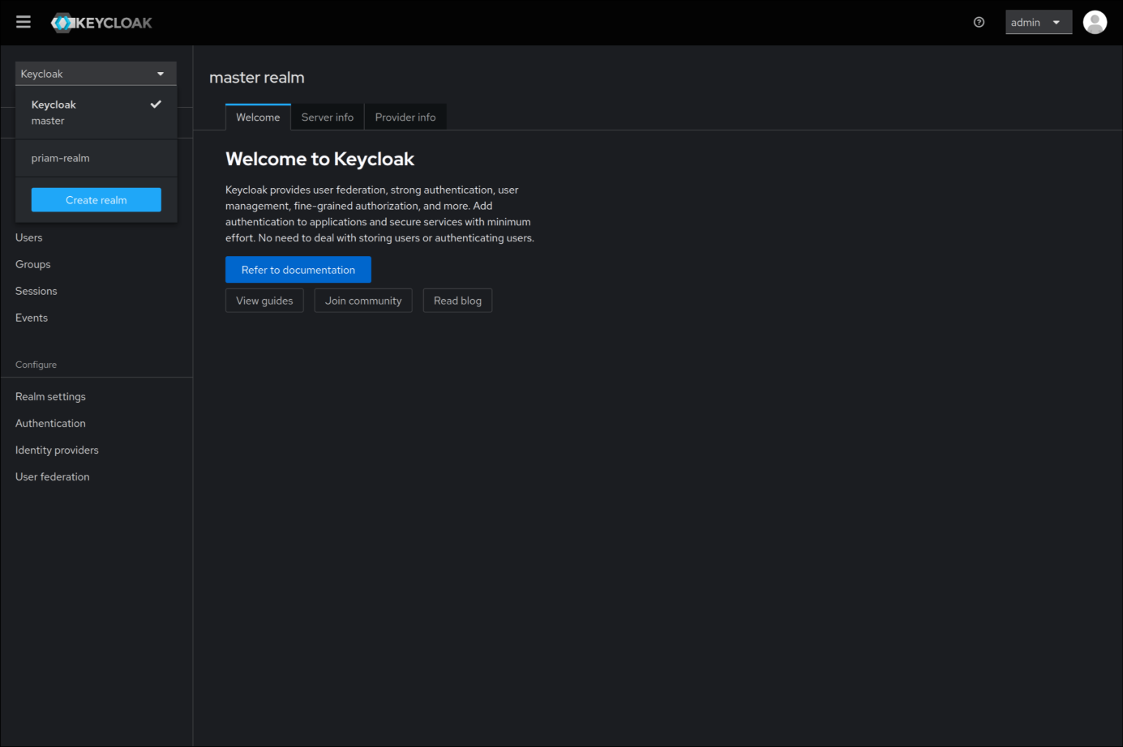

Now click on "create realm" and you will see this page:
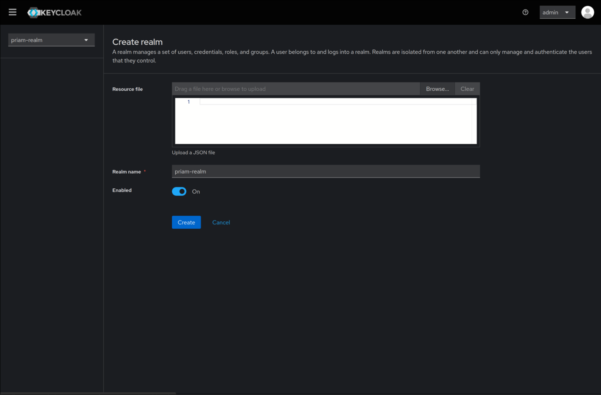
Copy exactly what is on the page, then go to realm settings at the bottom right: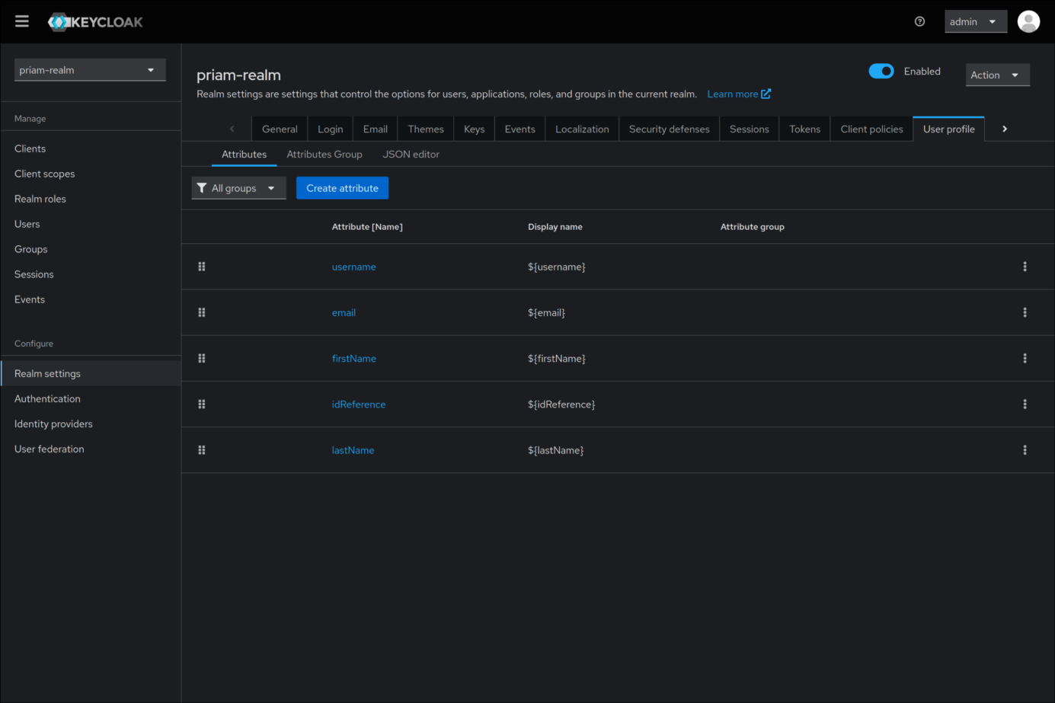

The page should look like this. Click on Create attribute:
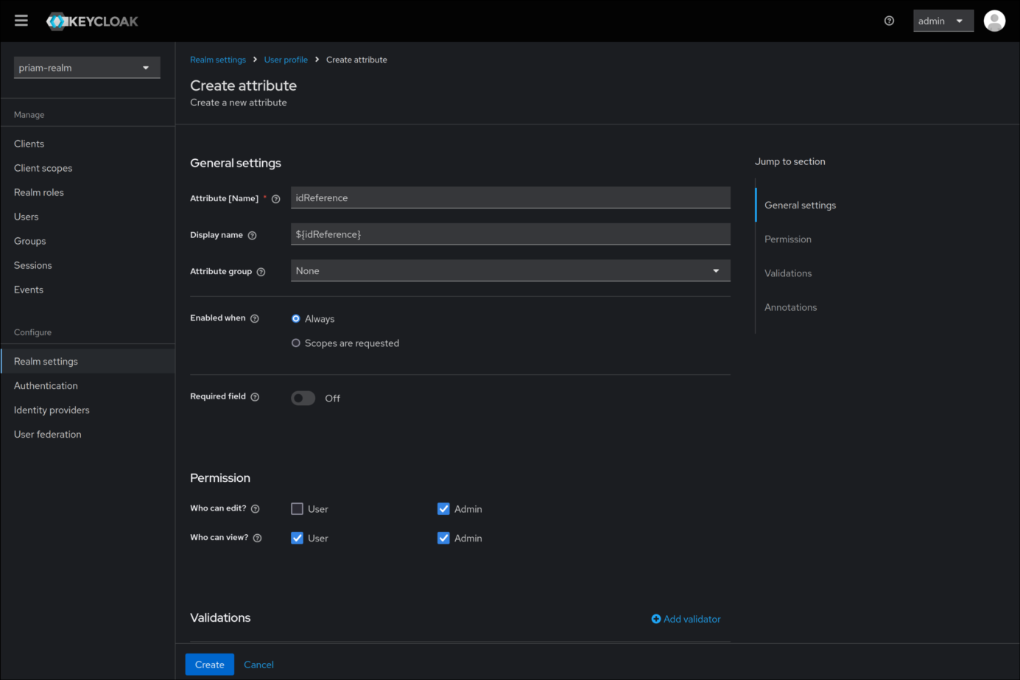
You will see this page. Fill it out exactly as shown, then go to the Clients page. By the end of this section, it should look like this:
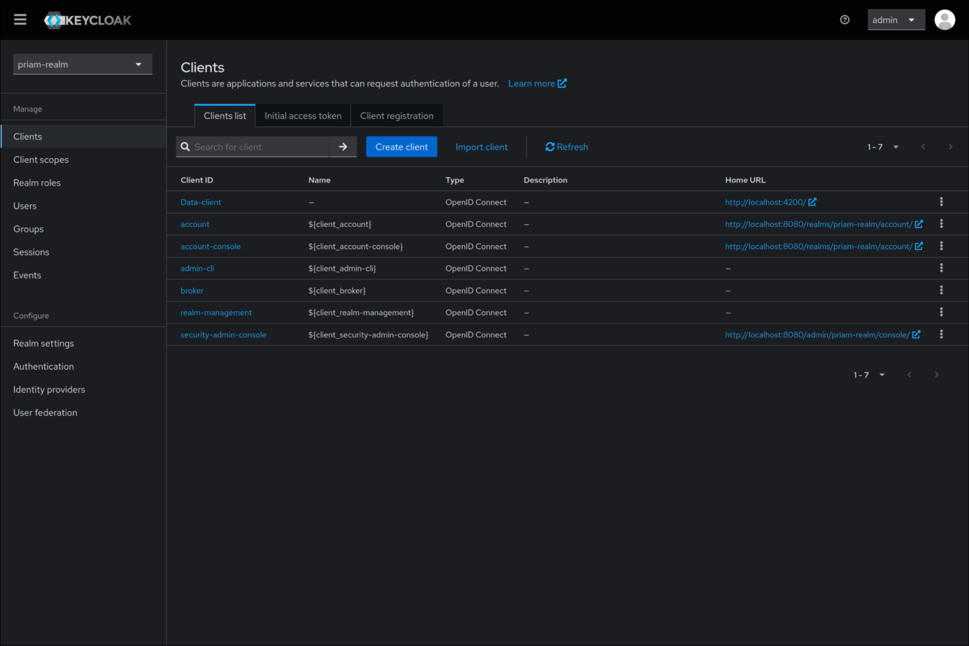
Click on Create client and fill out the page exactly as shown:
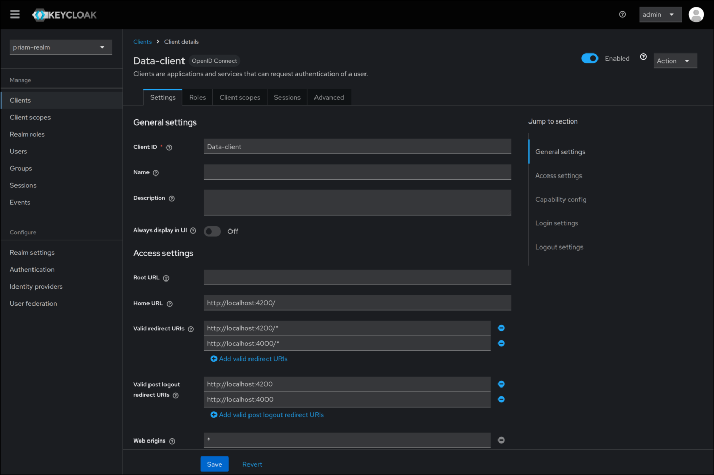
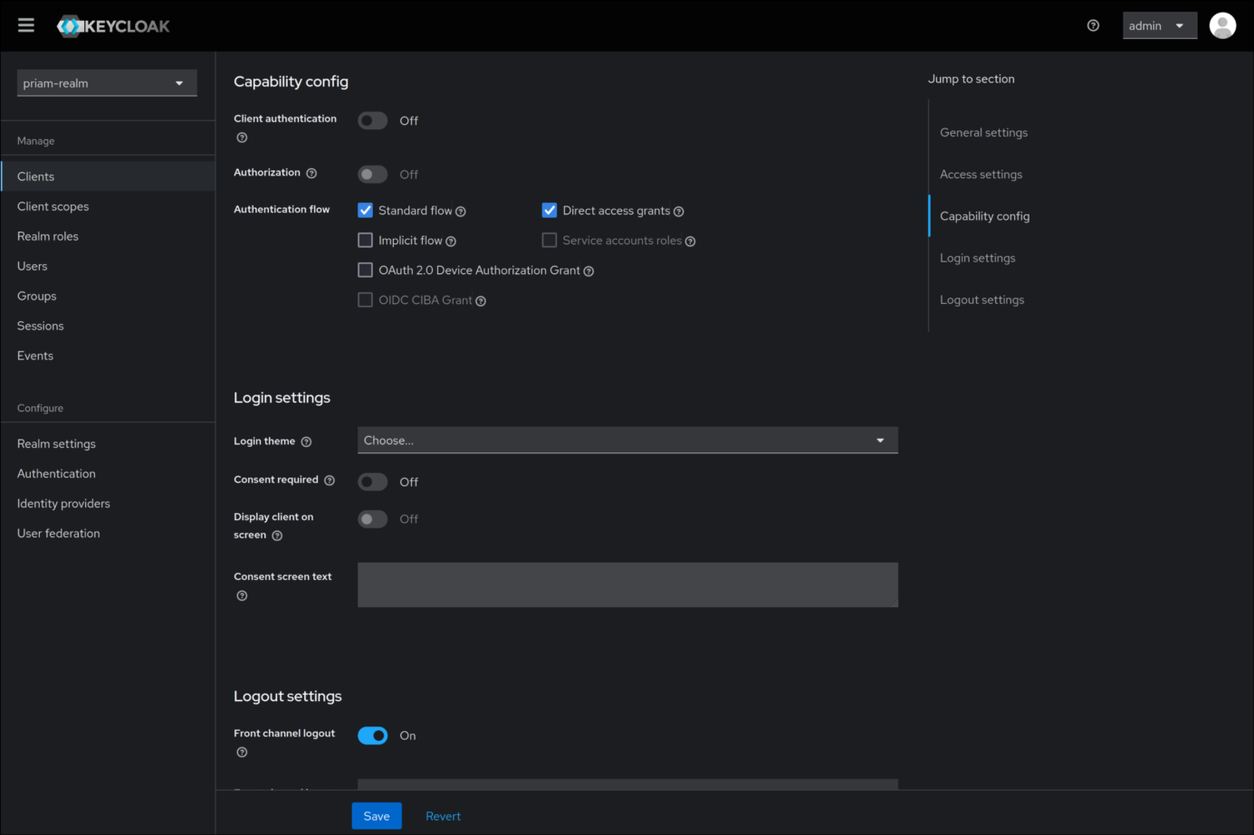

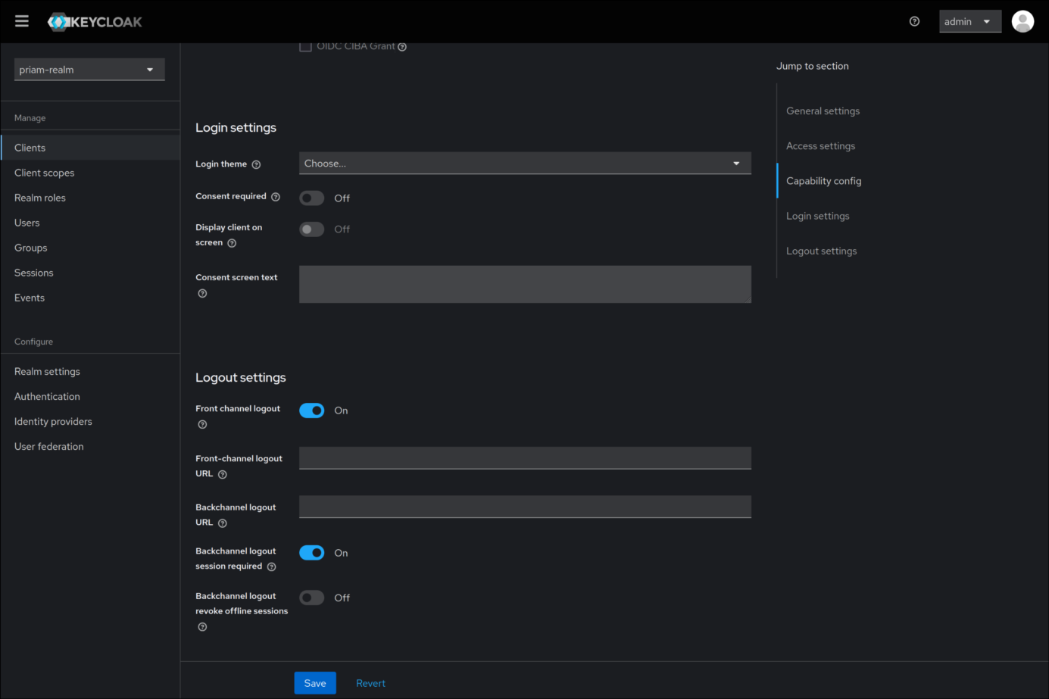
We're now going to create users.There are two ways of doing this:
-Connect Keycloak to the application provider's database (make sure that the idref of users in Keycloak is equal to the id of datasubject),
-fill in all users manually (for a test exercise, fill in only a few) (the idref will take the values of the user IDs in the database).
in our case, we'll use the second method
Start by going to the Users page on the left.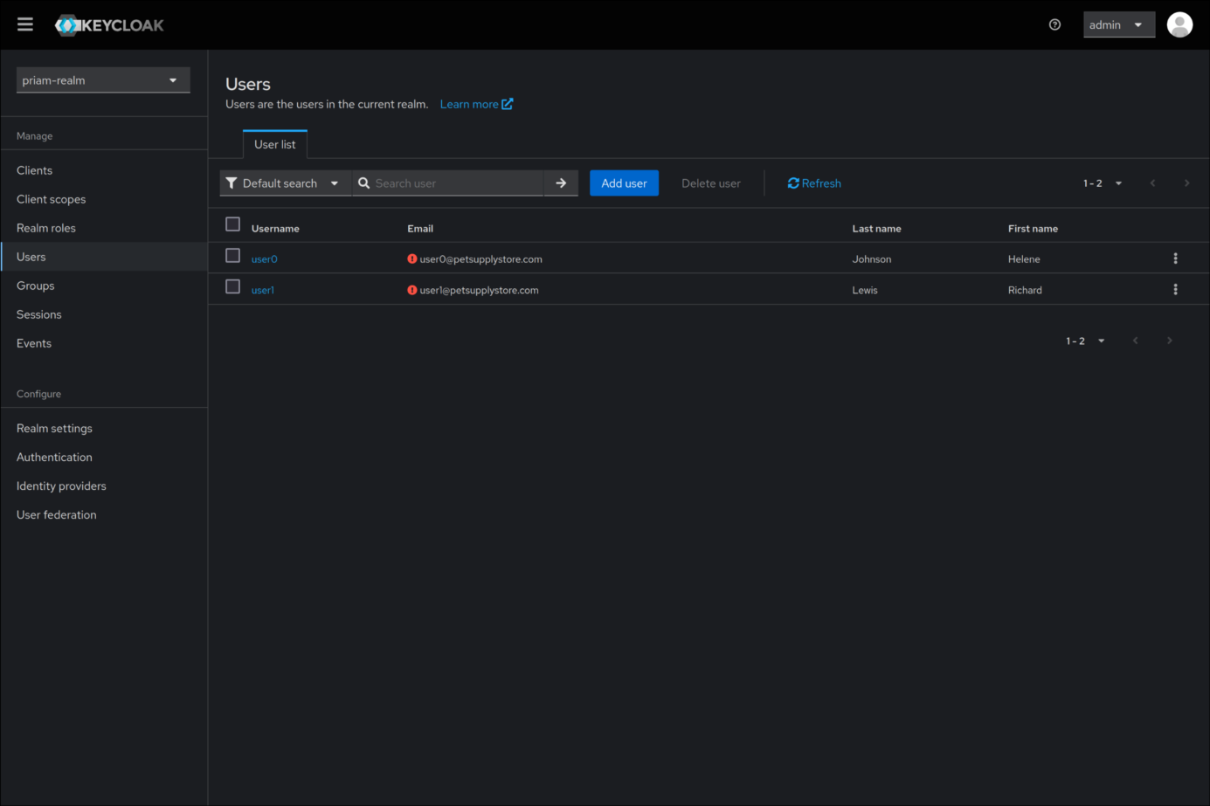

Click on Add user and copy the values exactly as shown.
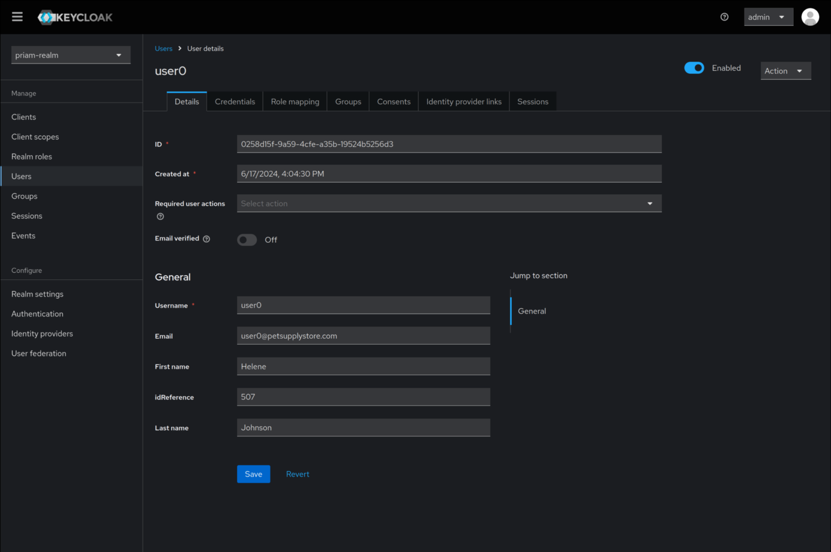
Now you need to do exactly the same for user1:
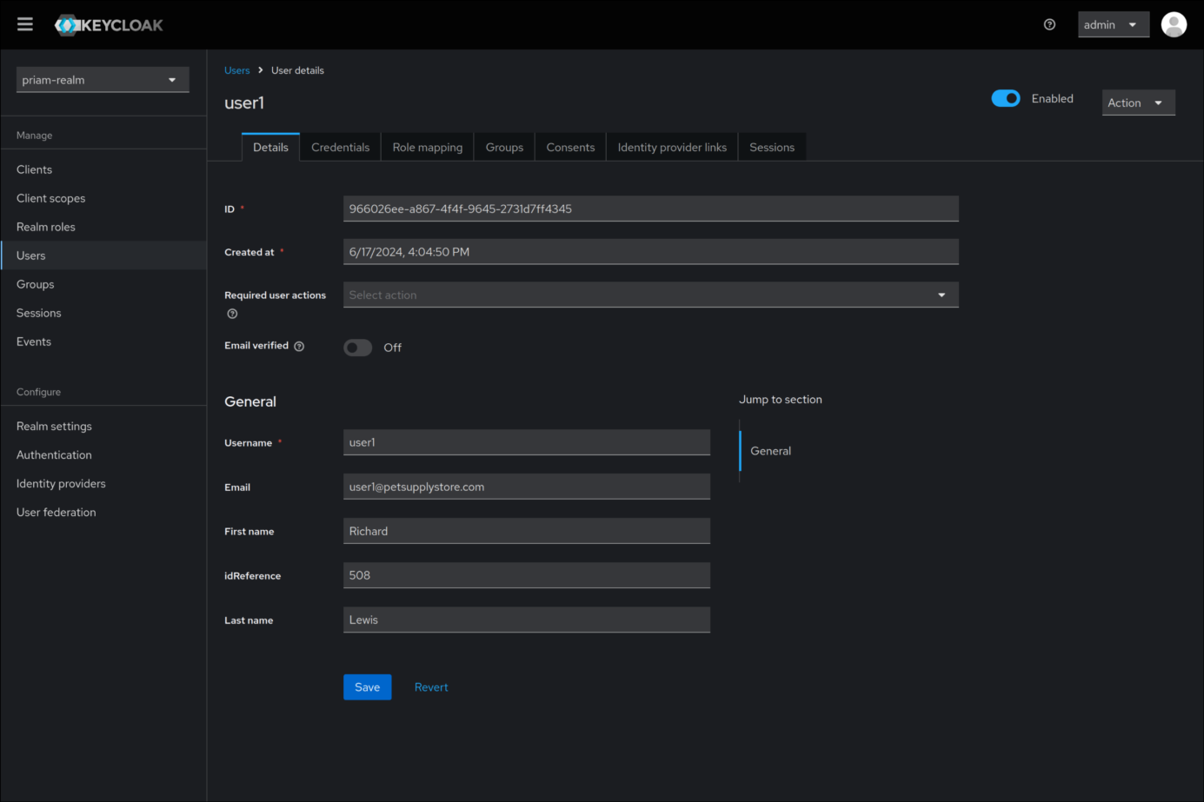
Next, we need to create login credentials for user 0. Go back to user0 and go to Credentials:
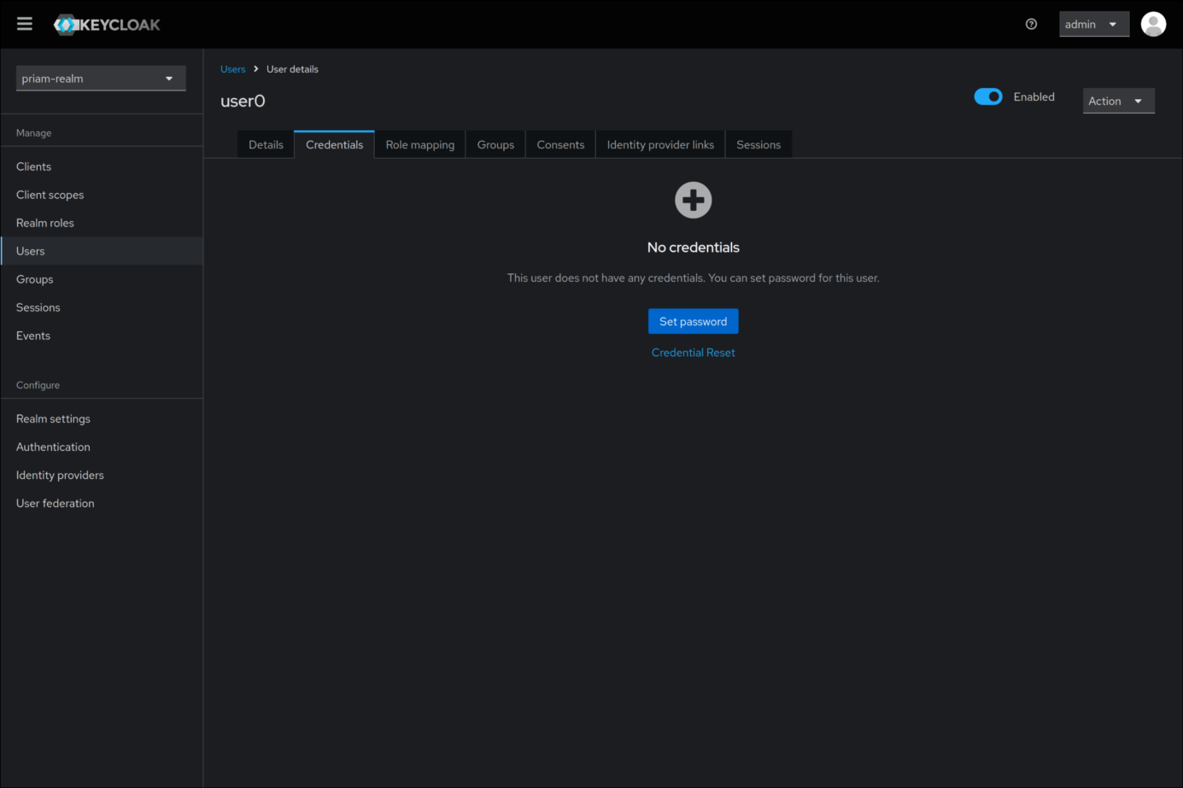
Click on Set password and fill out the page as shown:
Uncheck "Temporary" to avoid creating users each time.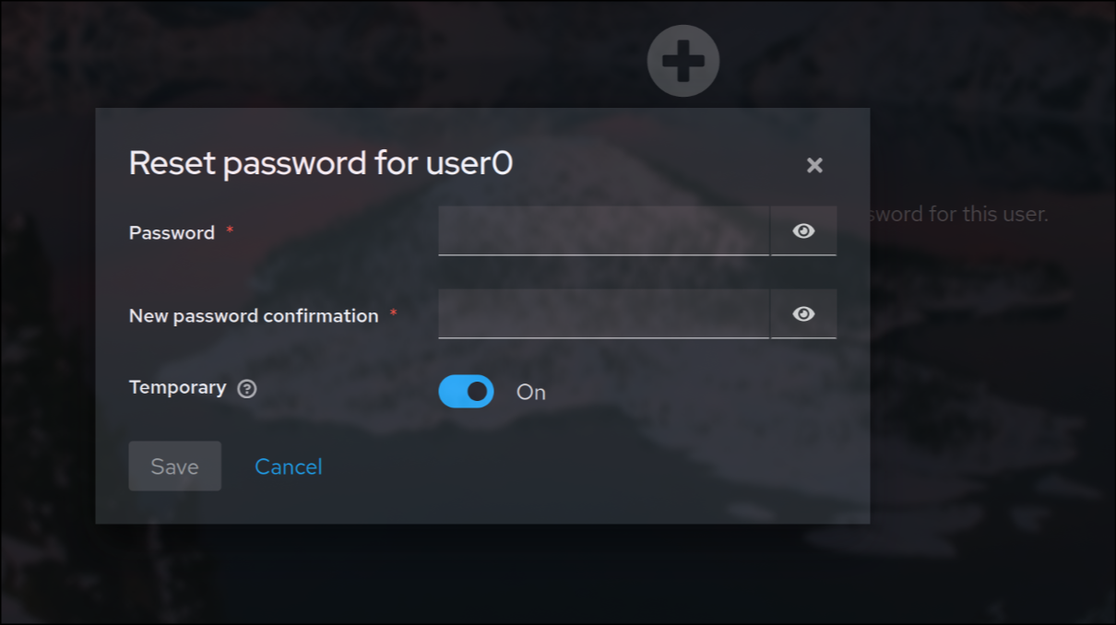

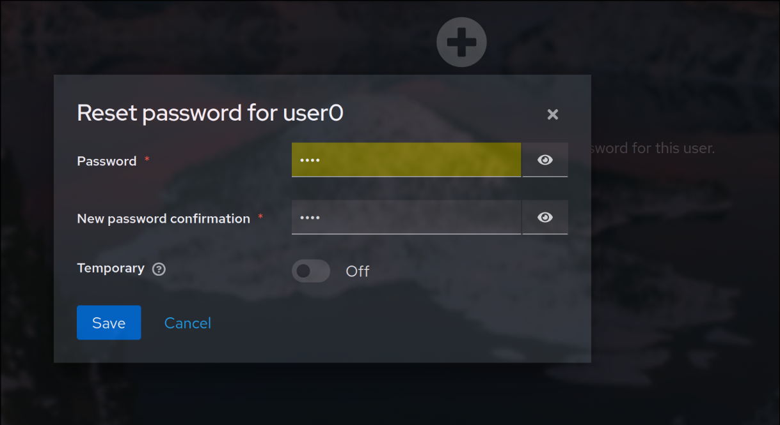
Choose a password that you will remember!

Don't forget to also add the application provider to Keycloak to ensure centralized user and permission management. This ensures that access to APIs and data is secure and compliant with the application's authentication policies.

PRIAM Integration Documentation

Step 1: Database Creation
- Create the PRIAM Databases
In MySQL, create the required PRIAM databases using the script generated earlier by the DSL, titled "PRIAM-GDPR." After this step, you should see the following five databases created:
  - priam-actor
  - priam-data
  - priam-consent
  - priam-right
- Execute Annotation Scripts
  - Execute the "Actor Annotation" script in the priam-actor database.
  - Execute the "Data Annotation" and "Processing Annotation" scripts in the priam-data database.
- Clone the Microservices
Clone the available microservices from this link.
- Open Microservices in IntelliJ
Open the cloned microservices project in IntelliJ IDEA.

Initialization script
If your application already contains existing users in the database, you'll need to populate the data-subject class of the priam-actor DB. In this script, each idC (customer identifier) must correspond to the customer id.
Note: The type of the idC column must be a varchar to guarantee optimum compatibility with existing data.

Step 2: Frontend Setup
-Add a button (Privacy rights) on the main page of the provider's application that redirects to the PRIAM front-end.
- Install Frontend Dependencies
For the frontend microservices, navigate to each microservice's directory and run the following command to install the necessary dependencies:
npm install
- Configure Keycloak
Ensure that Keycloak is properly configured for authentication purposes, as it will be essential for managing user access across the microservices.

